Data Visualization Lab – Activity 1

Scenario 1 – Student Academic Performance Dashboard
Code
import pandas as pd
import seaborn as sns
import matplotlib.pyplot as plt

url = "https://raw.githubusercontent.com/mwaskom/seaborn-data/master/exercise.csv"
df = pd.read_csv(url)

sns.scatterplot(data=df,
x="pulse",
y="time",
hue="kind",
s=100)

plt.title("Student Academic Performance")
plt.xlabel("Attendance (%)")
plt.ylabel("Internal Marks")
plt.show()

Output
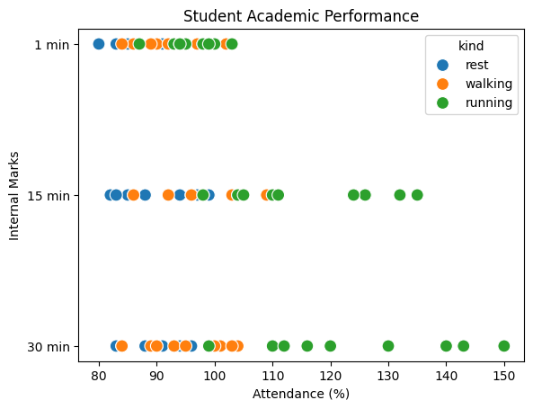

Scenario 2 – Electric Vehicle Market Analysis
Code
import plotly.express as px

df = px.data.gapminder().query("year==2007")

fig = px.scatter(df,
x="gdpPercap",
y="lifeExp",
size="pop",
color="continent",
title="Electric Vehicle Market Analysis")

fig.show()

Output
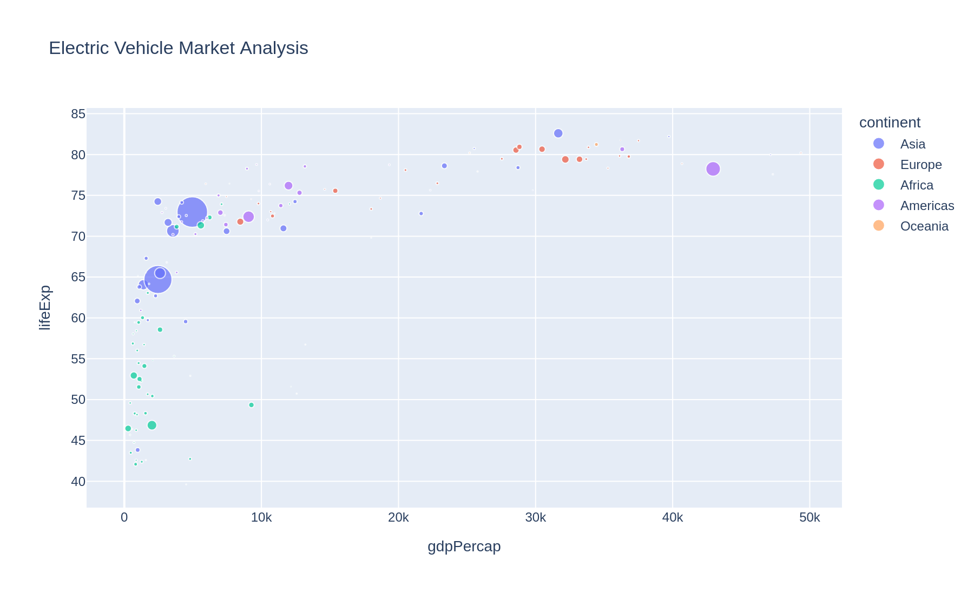

Scenario 3 – Hospital Patient Admission Analysis
Code
import seaborn as sns
import matplotlib.pyplot as plt

tips = sns.load_dataset("tips")

ax = sns.barplot(data=tips,
x="day",
y="total_bill",
hue="day",
palette="Set2")

for container in ax.containers:
ax.bar_label(container, fmt="%.1f")

plt.title("Hospital Patient Admission Analysis")
plt.show()

Output
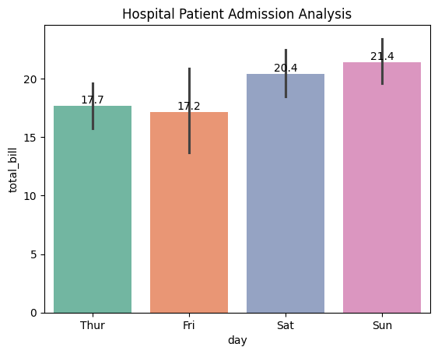

Scenario 4 – Weather Monitoring System
Code
import plotly.express as px

df = px.data.stocks()

fig = px.line(df,
x="date",
y=["GOOG","AAPL","AMZN"],
title="Weather Monitoring System")

fig.show()

Output
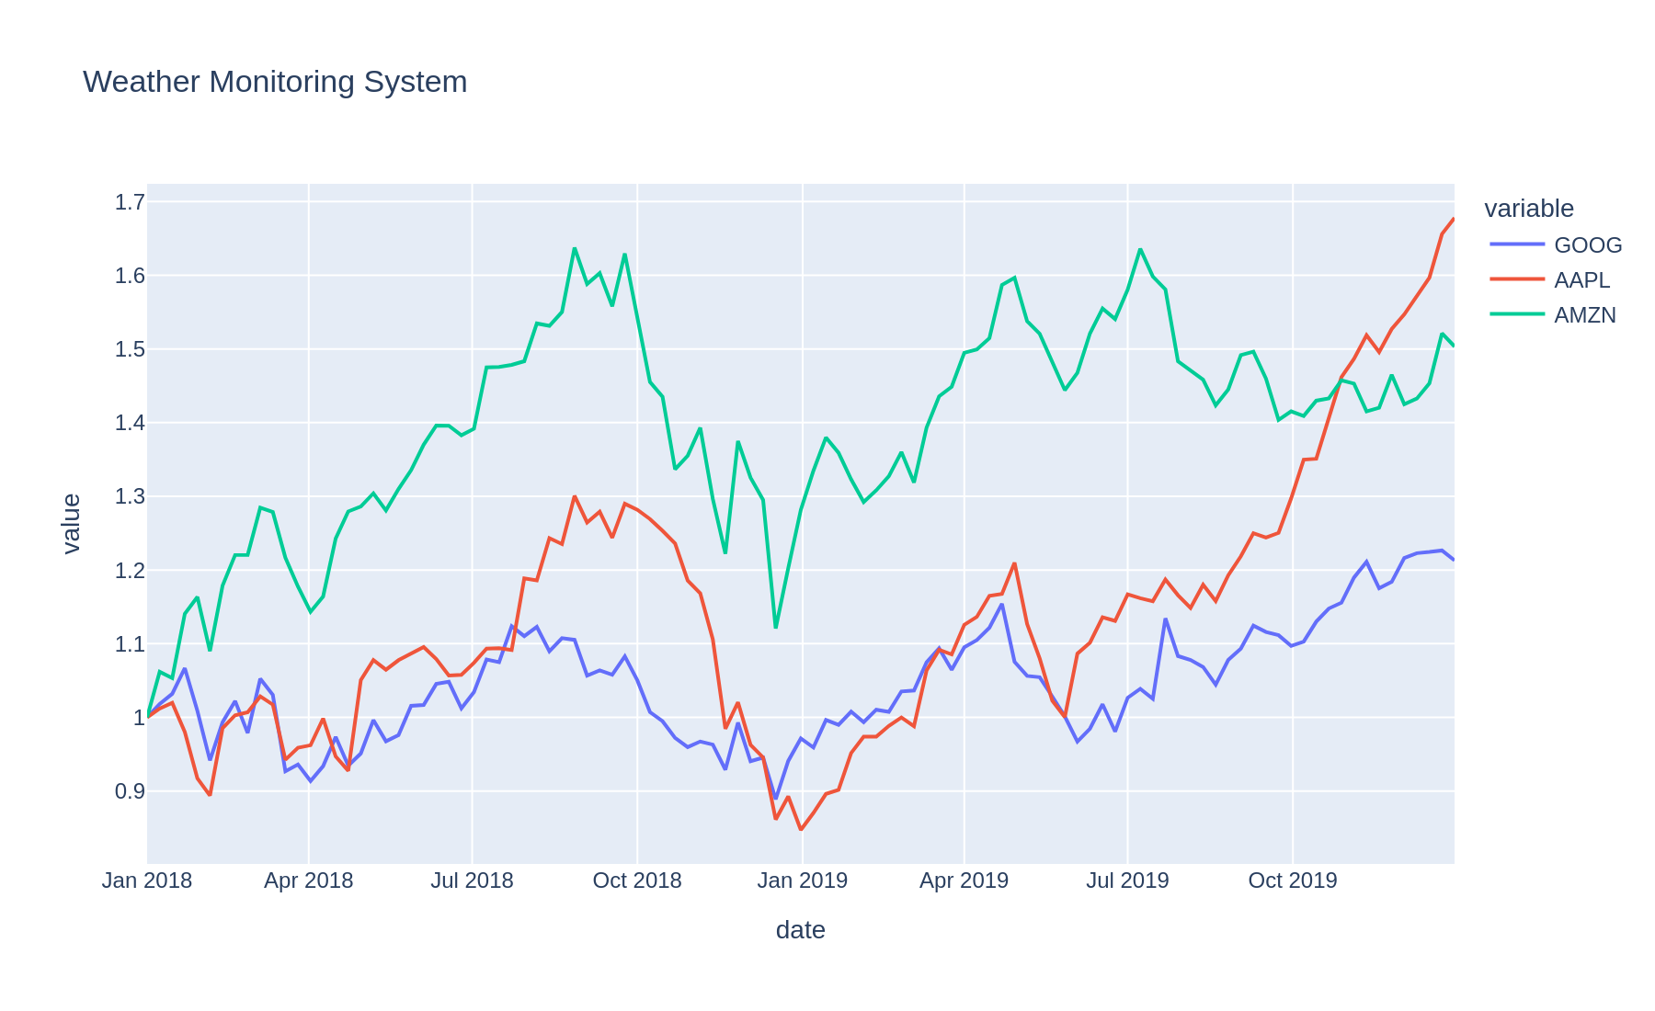

Scenario 5 – Supermarket Sales Analysis
Code
import seaborn as sns
import matplotlib.pyplot as plt

tips = sns.load_dataset("tips")

sns.barplot(data=tips,
x="day",
y="total_bill",
hue="sex")

plt.title("Supermarket Sales Analysis")
plt.show()

Output
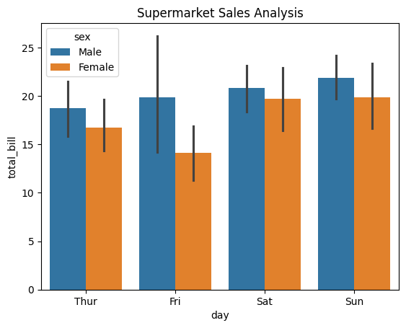

Scenario 6 – Employee Salary Distribution
Code
import seaborn as sns
import matplotlib.pyplot as plt

tips = sns.load_dataset("tips")

plt.hist(tips["total_bill"],
bins=10,
edgecolor="black")

plt.title("Employee Salary Distribution")
plt.xlabel("Salary")
plt.ylabel("Frequency")
plt.show()

Output
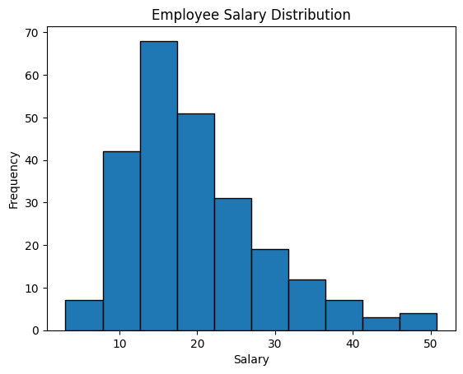

Scenario 7 – Smartphone Market Comparison
Code
import plotly.express as px

df = px.data.iris()

fig = px.scatter(df,
x="sepal_width",
y="petal_length",
color="petal_width",
symbol="species",
size="sepal_length",
title="Smartphone Market Comparison")

fig.show()

Output
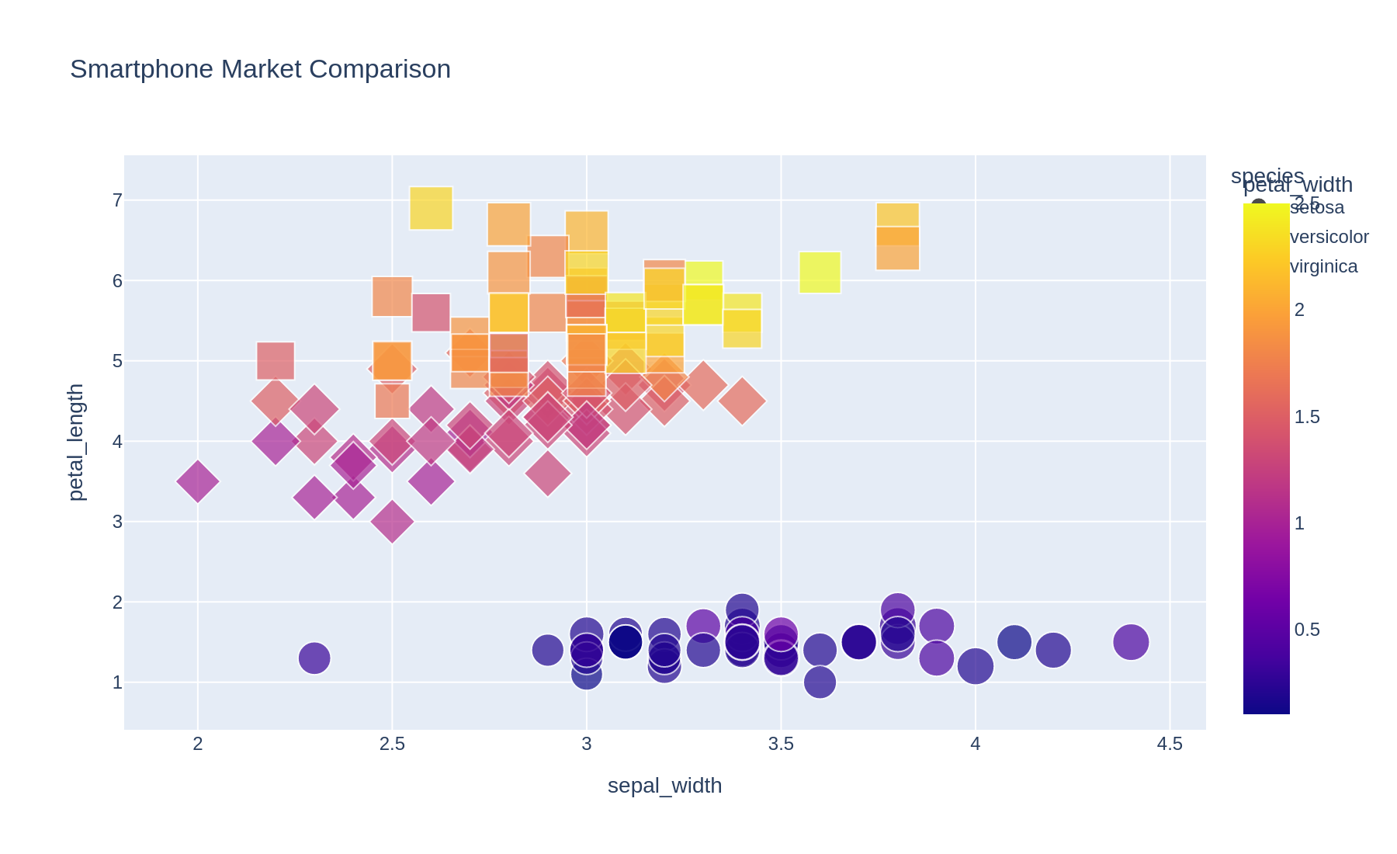

Scenario 8 – Online Movie Rating Analysis
Code
import plotly.express as px

df = px.data.medals_wide()

fig = px.imshow(df.set_index("nation"),
color_continuous_scale="Viridis",
title="Online Movie Rating Analysis")

fig.show()

Output
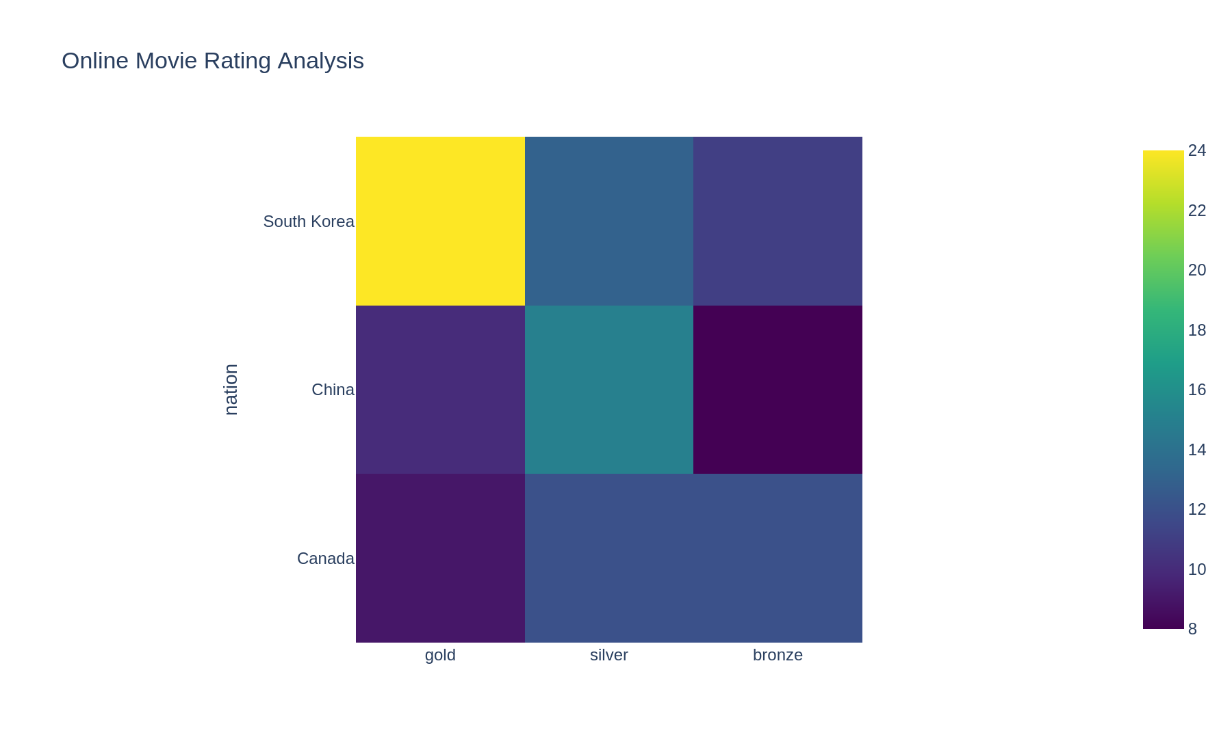

Scenario 9 – COVID-19 State-wise Analysis
Code
import plotly.express as px

df = px.data.election()

fig = px.density_heatmap(df,
x="district",
y="Coderre",
z="Bergeron",
color_continuous_scale="Reds",
title="COVID-19 State-wise Analysis")

fig.show()

Output
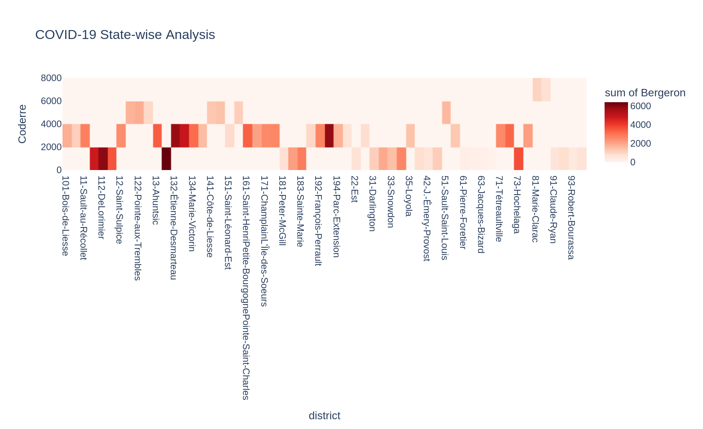

Scenario 10 – Iris Flower Classification
Code
import plotly.express as px

df = px.data.iris()

fig = px.scatter(df,
x="sepal_length",
y="petal_length",
color="species",
symbol="species",
size="sepal_width",
title="Iris Flower Classification")

fig.show()

Output
